Beneficiary Assessment Field Testing Logistics and Description (Template)
On [Date X] and [Date Y], field testing of tools and processes of the Beneficiary Assessment (BA) of the [Project name] in [Location e.g. District name] will take place. This document describes the main elements and logistics of this exercise.

Overall description for [Location] representatives
[Here a brief description of the project for local community representatives could be provided. The example of a water sector project in Ethiopia is used in this template]. Organisations X and Y are working with a small group of community members from Miyo district of Borana for them to discuss changes in people’s lives after water sources have been rehabilitated or constructed by the project. Such an exercise will be carried out by selected members of the community who are also benefiting from the development initiative. Following a two day intensive training, these community members will be given an opportunity to do a first exercise in a community, to get a better idea of how they can do this work, and in a way that gives an opportunity for the community at large to be part of the process and contribute to the tools as well as skills of members selected from the community. (Note: this description should be shared with community leaders when the field test is being organised).

Model for Household, Focus Group Discussion and Community Meetings
In order to give each pair of Citizen Observers (COs) a chance to practice household (HH) interviews, Focus Group Discussions (FGDs) and Community meetings, visits to communities benefitting from two different water sources built/rehabilitated by the project will be conducted. The first is [Community A] (two wells) and the second is [Community B]. The following diagram outlines the mix of water sources, HHs, FGDs and community meetings….

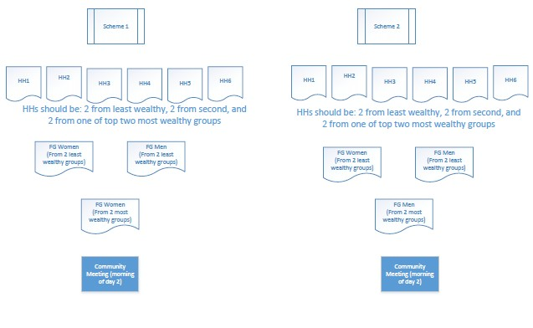

In total there are 14 COs (including two backup COs in case of absences during field research), from which we will make 7 pairs. Using the above diagram as a basis, arrangements will be made for COs to visit all HHs and to hold all FGDs on Day 1 [Include date here], and to facilitate community meetings on Day 2 [Include date here].

HH visits (Timing: 9:00 – 12:00)
Of the 7 CO pairs, 3 pairs will go to Scheme 1 and 3 pairs will go to Scheme 2. In addition, each of the reserve COs will accompany one CO pair as an observer. Each CO pair will visit 2 HHs. This will give each CO a chance to lead one HH conversation and to be a note-taker for one HH conversation.

FGDs (Timing 13:00 – 14:30)
In each scheme, there will be one Female focus group composed of women from the two least wealthy social groups [note – the two least wealthy groups are Group W and Group X] and one Male focus group composed of men from the two least wealthy social groups . In addition, in Scheme 1, there will be a Female focus group composed of women from the two most wealthy social groups, and in Scheme 2, there will be a Male focus group composed of men from the two most wealthy social groups [note – the two most wealthy groups are Group Y and Group Z] . In this way, each scheme will have three focus groups (the FGDs take place in separate locations), so that each pair of COs will have a chance to facilitate and take notes from one focus group discussion.
When the FGDs are completed, the COs, facilitators and others will return to the training venue (leaving time from the local communities: 15:00).

Community Meetings
Finally, in each scheme, a community meeting will be organised, for which one CO will play a facilitator role, while one (or more) other CO(s) will serve as a note-taker. The remaining COs will be observers.

Timing:
While HH conversations are expected to be completed the morning of Day 1, COs will proceed to FGDs in the afternoon of the same day. Community meetings will be organized early morning of Day 2 at a common place within the village in corresponding to respective water source users.

